Git guide

By Peter Lowe

# Git rm

Git rm to remove file(s) from the staging area.

Format git rm filename

Can use wildcards and -r for recursive

Use - - cached to remove from staging area

Use -f to use on working directory

# Clone

Git clone url

Make a local caopy of repo

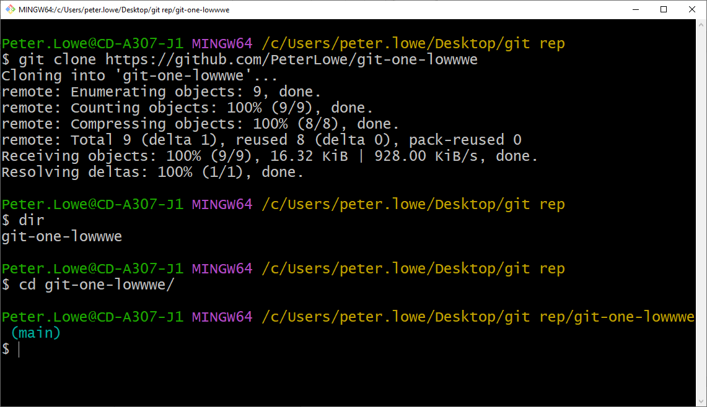

Cd into the folder

